**Tableau Conference 2019** Tableau + Python Lab Instructions

# Installation and TabPy Server Startup

## Installing Python

Python 3 has already been installed on your training machine from https://anaconda.com/distribution

Anaconda is a convenient way to install Python plus Jupyter notebooks and all the tools needed for a complete data science workstation.

## Installing TabPy

## **Start an Anaconda command prompt.**

* **At the Anaconda command prompt, type: “pip install tabpy”**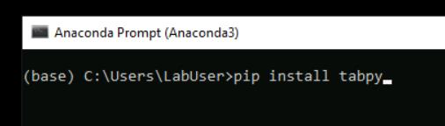
* **At the Anaconda command prompt, type “pip install tabpy_client”**
* **At the command prompt, start TabPy by typing: “tabpy”**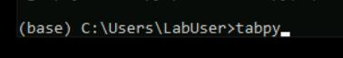

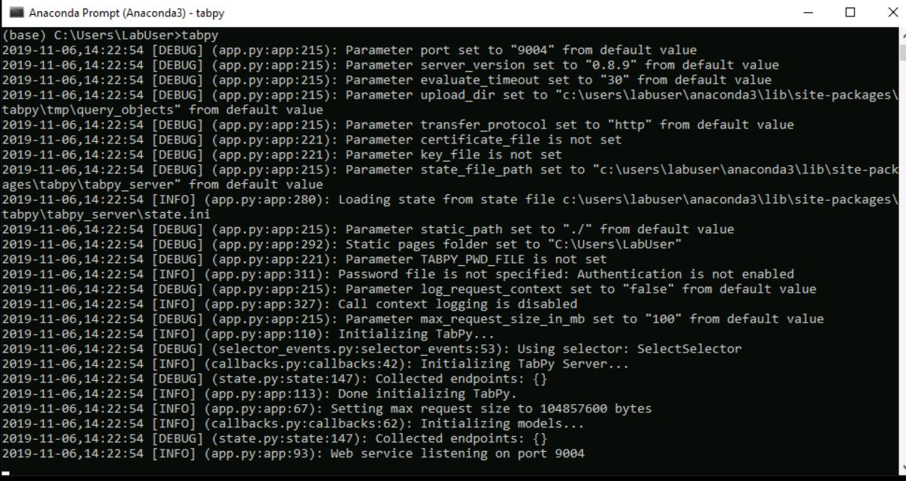

Be sure to **note on which port tabpy is running**. This will be the last output line from startup.cmd.**9004 is the default**.

## Tableau Desktop

* **Open Tableau Desktop 2019.3**.

### Connecting Tableau Desktop to TabPy

* To connect Tableau Desktop to your TabPy server: **Select the Help menu, then select Manage External Service Connection** 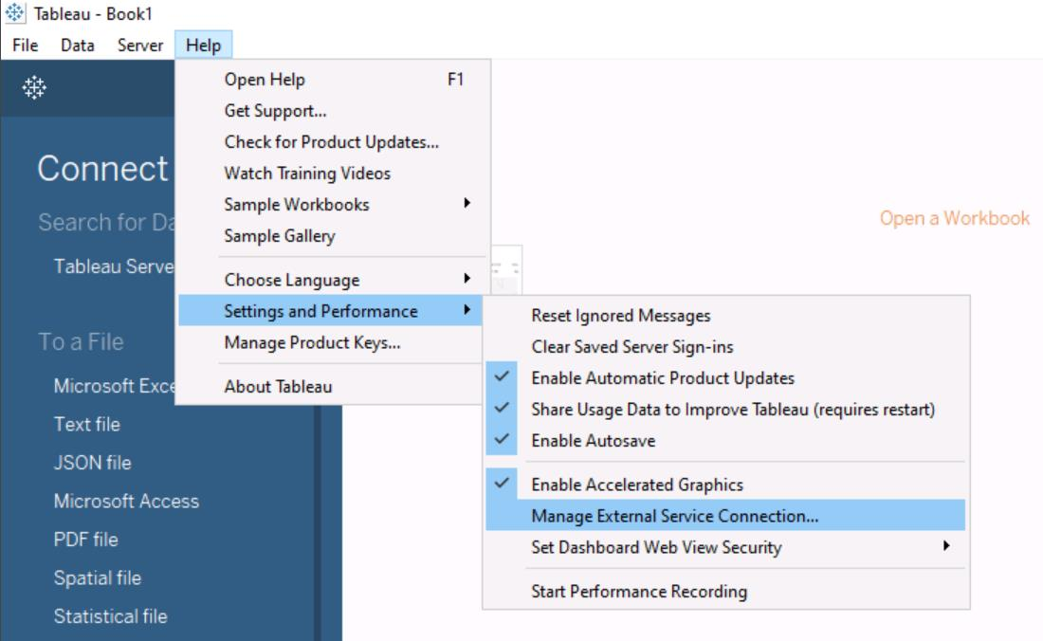
* **Enter the server name or ip address of the machine on which TabPy is running.** In this case, "localhost" since it's running on the workstation that you are using. **Enter the port number that you observed when you started TabPy (9004)**.
* We have not configured any security on our TabPy server, so **leave the "sign in" and "Require SSL" boxes unchecked**.

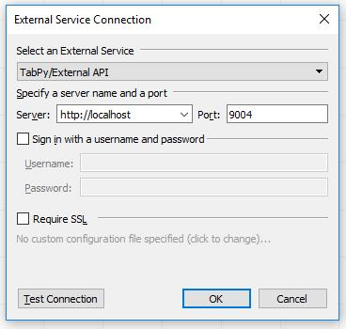

# Executing Python Scripts from Tableau Desktop

Tableau can pass code to TabPy through one of four different functions: SCRIPT_INT, SCRIPT_REAL, SCRIPT_STR and SCRIPT_BOOL. Each of these accommodates a different return type.

## Exercise 1

* In Tableau Desktop, **Connect to the SuperStore sample dataset**.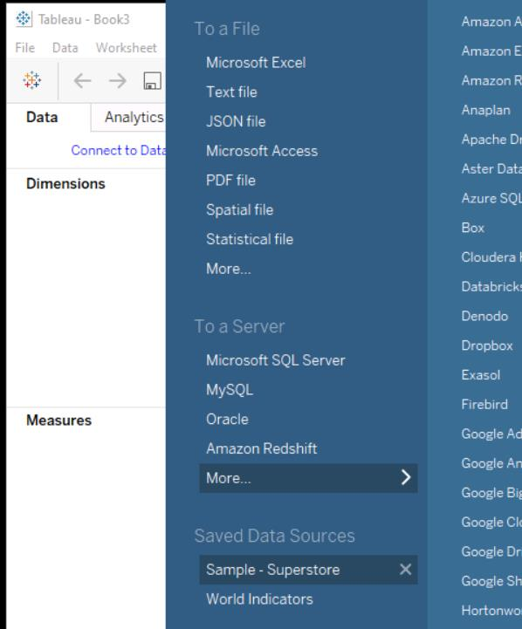
* **Create a calculated field** by selecting the Analysis menu / Create a Calculated Field…
* **Name this new calculation "Region Country"**
* **Type the following formula:**

SCRIPT_STR("

print(_arg1)

print(_arg2)

lst=[]

for i in range(0,len(_arg1)):

lst.append(_arg1[i]+', '+_arg2[i])

return lst

",

ATTR([Region]),ATTR([Country])

)

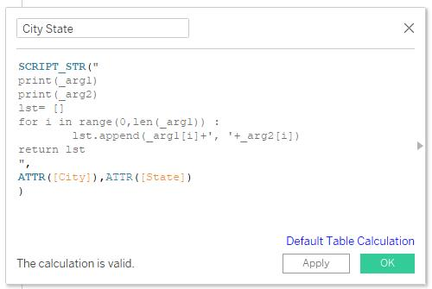

* On an empty worksheet **Drag:**

**year of Order Date to columns.**

**Region to Rows,**

**Sales to rows.**

* **Drag the new Region Country calculation to color.**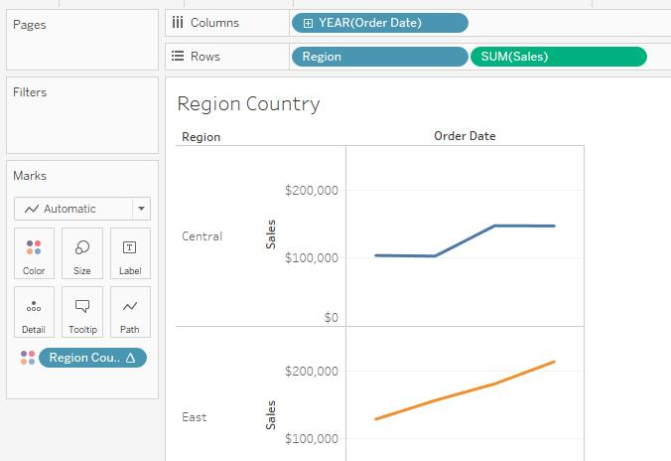

Observe the result of the RegionCountry calculation in the tooltip.

## Exercise 2

* **Create a calculated field** by selecting Analysis / Create a Calculated Field…
* **Name this new calculation "Discount Profit Correlation"**

SCRIPT_REAL("

print(_arg1)

print(_arg2)

import numpy as np

return np.corrcoef(_arg1,_arg2)[0,1]"

,SUM([Discount]),sum([Profit])

)

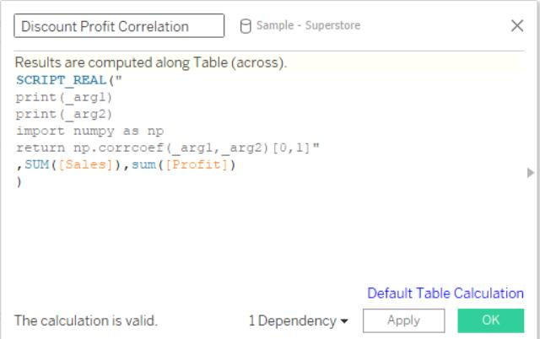

* On the new sheet you created, **drag**

**Region to columns**

**Segment to rows**.

* **Drag SalesProfitCorrelation to Text in the Marks ledge, or just double-click on it**.

Notice that sales and profit are more highly correlated for the consumer segment and the corporate segment than for the home office segment.

Reference "Using Python in Tableau Calculations" here: https://github.com/tableau/TabPy/blob/master/docs/TableauConfiguration.md

# Using Deployed Functions from Tableau Desktop

## Exercise 3

* **If you did not do so in exercise 1, in a new Anaconda prompt, type "pip install tabpy_client" to install the libraries necessary for Python to interact with TabPy.**
* **Start Jupyter Notebook (Anaconda3)**. (Do not use the rServe Jupyter notebook for this lab.)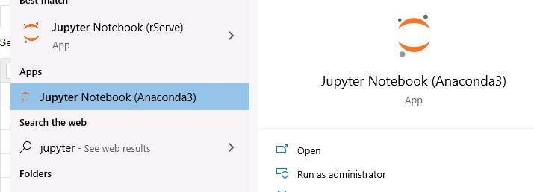
* **In Jupyter Notebook, open "ProfitPerUnit TabPy" from C:\Users\LabUser\Documents\GitHub\TableauPrepPythonTitanic\TC19\** 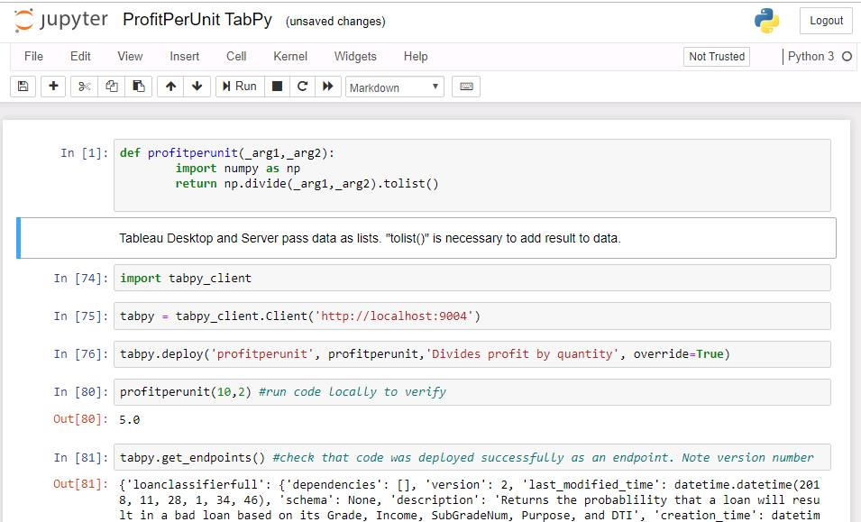
* **In each cell sequentially, press Shift+Enter to execute the Python code for that cell.**
* **In Tableau Desktop, create a “Profit Per Unit” calculation with the following script:**

SCRIPT_REAL("

return tabpy.query('profitperunit',_arg1,_arg2)['response']",

SUM([Profit]),SUM([Quantity]))

* **Explore Superstore with the new Profit Per Unit calculation.**

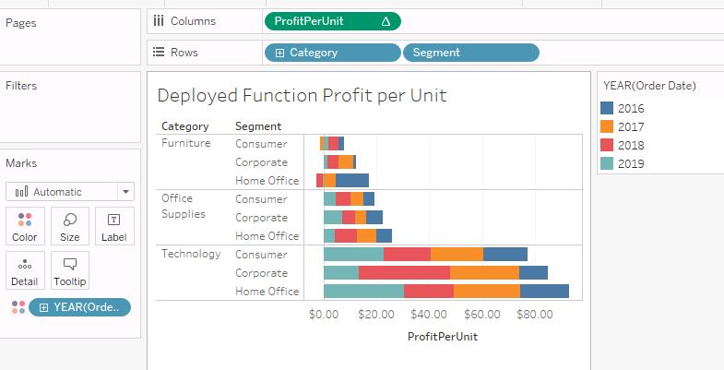

# Using Python with Tableau Prep Builder

## Connecting to TabPy from Prep Builder

### Exercise 4

* **Open Tableau Prep Builder**
* **Open the Superstore Sample flow**
* **Click the plus icon to the right of the "Clean 2" step**
* **Select Add Script**

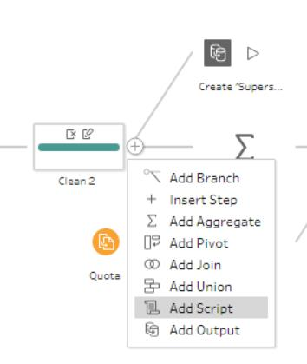

* **In the Settings panel at the left edge of the Prep builder UI, Select "Tableau Python (TabPy) Server" as the Connection type**
* **Click "Connect to Tableau Python (TabPy) Server"**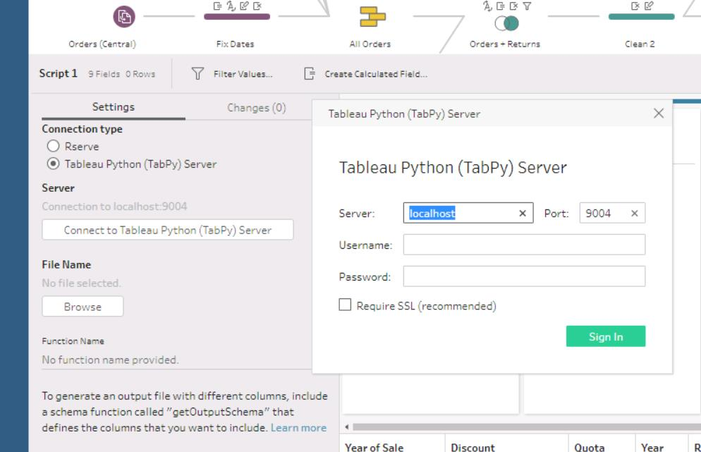
* **Enter "localhost" as the server and port 9004**

### Write the Python script

* **Open Visual Studio Code**

Exercise scenario: Sales management would like to gain insight on the revenue effect if discounting. To support this, we will use Python to add a field to our flow called "non-discounted sales". (This simple math could easily be done with Tableau Prep Builder functionality or in a Tableau Desktop calculation. We are using this simple scenario for learning purposes.)

In this context, our Python script must be written with a function that can be called from Prep Builder. We choose the name of this function. It will accept a structure called a dataframe, and will return a dataframe.

* **Create a new file called nds.ps (nds = non-discounted sales).**

First we'll simply print the dataframe to get a look at what our function will receive from Prep Builder.

* **Add the following Python code to nds.py:**

def nds(df):

print(df)

return(df)

* **Save the file to your Documents directory. (The location does not matter as long as you can find it later.)**
* **In the Prep Builder configuration panel for the script added above, browse to the nds.py file to connect this script step to your new Python script.**
* **Look at the command prompt running TabPy. You should see the results of the print statement.**

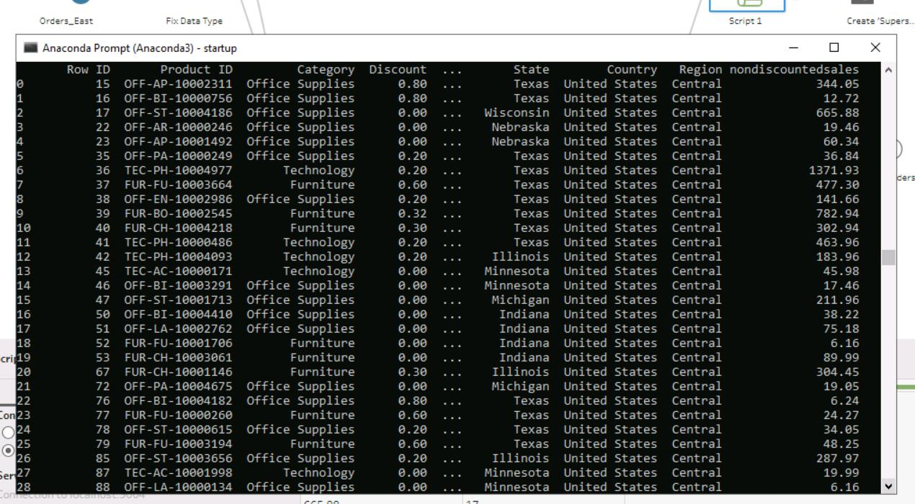

* Let's add our calculation. **Replace the print(df) statement with the following:**

df['Non Discounted Sales'] = df['Sales'] / (1-df['Discount'])

This line creates a new column in the dataframe called "Non Discounted Sales".

* **Be sure the two leading spaces are included. The Python specification requires the contents of a function to be indented.**

If the schema of the returned dataframe does not exactly match that of the calling dataframe, we need to include an additional function called "get_output_schema".

In this case we will return our new "Non Discounted Sales" column along with the "Row ID" column so that we can join this column back into the flow.

* **Add the following to nds.ps:**

def get_output_schema():

return pd.DataFrame({

'Row ID': prep_int(),

'Non Discounted Sales': prep_decimal()

})

* **Save the file.**
* **In Prep Builder, in the flow, click off of the script step icon then back on it. This will cause Prep Builder to re-execute the Python script.**

You should see the result of the script in Prep Builder.

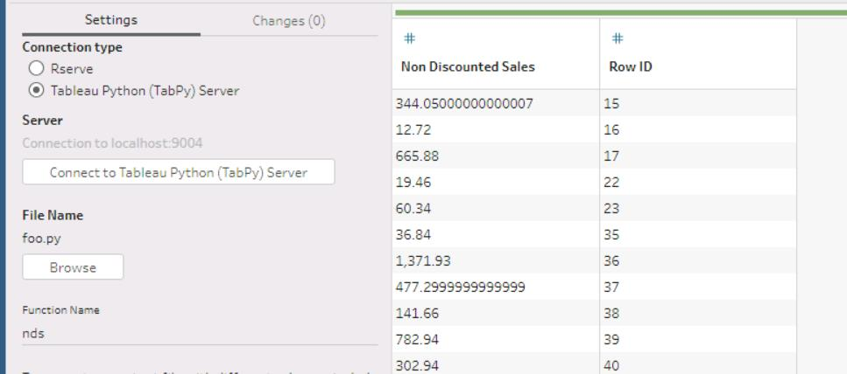

* **Join the result of the script to the flow before the "Create Superstore Sales.tde" output step by dragging the “Clean 2” step icon over the “Non Discounted Sales” script step icon, and dropping it on the “Join” area that appears.**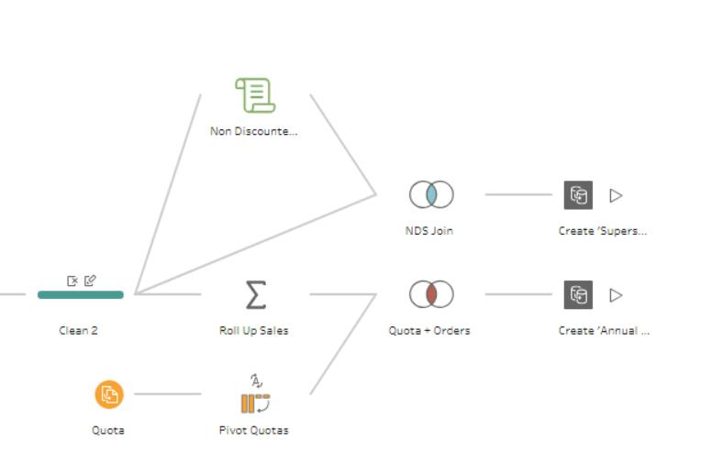

# Extras

Browse to https://www.tableau.com/about/blog/2019/10/using-tableau-preps-new-python-integration-predict-titanic-survivors and use the code at https://github.com/tabblogs/TableauPrepPythonTitanic to explore further.

## Thank You for being a Tableau Customer!